Climate Change Update Report – February 2021

Purpose of report
For direction.

Summary
At the end of January 2021, the Environment, Economy, Housing & Transport Board held a special climate change meeting on adaptation. We invited guest speakers from the Department for Environment, Food and Rural Affairs (DEFRA) and Local Partnerships to lead the discussion. This paper provides members with a reflection of the issues that were raised during the meeting and next steps, which includes a direction from Members to develop the Board’s policy lines on energy grid connection to deliver infrastructure. There is also an update on the LGA’s COP26 strategy.

Recommendation/s
That members provide direction on developing our lobbying on grid capacity to deliver infrastructure and a future discussion on low-carbon behaviour change.
That members reflect and provide any comments on the issues and work raised in this update.
Action/s
Officers to take forward any member comments for future policy work.

Contact officer: Hilary Tanner/Bethany Vella
Position: Senior Adviser/Adviser
Phone no: 0207 664 3039
Email: Hilary.tanner@local.gov.uk

Climate Change Update Report – February 2021
Background
- At the end of January 2021, the Environment, Economy, Housing & Transport Board held a special Climate Change meeting on adaptation. We invited guest speakers from the Department for Environment, Food and Rural Affairs (DEFRA) and Local Partnerships to lead the discussion. This paper provides members with a reflection of the issues that were raised during the meeting and next steps, which includes a direction from Members to develop the Board’s policy lines on energy grid connection to deliver infrastructure.

Summary of the special climate change meeting on adaptation
- The purpose of the meeting was to provide an opportunity to have a discussion about adaptation, as recent Board discussions have focused more on reducing carbon emissions (for example, debates on decarbonising transport). Tom Walker, Director for Environmental Strategy at DEFRA and Jo Wall, Strategic Director for Climate Response at Local Partnerships presented at the meeting which was followed by a panel question and answer. It was clear from the discussion that it is difficult to talk about adaptation as a distinct topic and rather, it is part-and-parcel of the whole climate agenda. However, the meeting helpfully raised a number of key issues for the LGA to consider further:
  - The need for a holistic approach to climate change that encompasses the wider green economic recovery and levelling up agendas. The LGA needs to be more robust about the links to skills and demonstrate the difference local government is making.
  - Challenges of local delivery as a result of a lack of powers, funding and skills and capacity within councils. Particular examples raised were housing retrofit, flood defences and deregulation of the electricity grid.
  - Fiscal barriers and concern over the effectiveness of funding schemes which are hampered by short timeframes and competitive application processes, for example, the Green Homes Grant.
  - Uncertainty over the geography and scale at which some projects need to be delivered at regional or sub-regional level, for example, flood defence schemes.
  - The need for greater cross-Whitehall coordination between Defra, BEIS and MHCLG and engagement between national and local government. There was also a reminder of the importance of local action, and the need for the response to climate change to be co-produced by councils and communities.
- As our next steps, we will seek to take forward DEFRA’s offer of coordinating greater engagement across government departments, such as with MHCLG and BEIS. In response to the issues raised in the discussion and feedback from councils, we will also explore where the LGA can develop further lobbying in line with forthcoming opportunities in the Energy White Paper and lead up to COP26. See policy development section below.
Policy development
- Climate change is high on the political agenda. Recent government commitments in the Ten Point Plan, Energy White Paper and new Nationally Determined Contribution, along with the publication of the Committee on Climate Change’s Sixth Carbon Budget signify government’s commitment to the UK being net zero by 2050 and the direction that government will take in meeting this target.
- There is less detail on how these commitments will be delivered and implemented. With announcements such as the creation of the first hydrogen-powered town, the roll out of electric vehicle charge points and district heating systems, and the installation of 600,000 heat pumps, there is a clear role for local government who are already leading the way and want to work with national government as delivery partners for addressing the climate emergency.
- There are a number of position statements and recommendations to government from the local government sector that seek to address the needs of councils to deliver. In response to feedback from the Board and our council networks that there is a fragmented approach across local government on climate change, officers undertook a high-level policy analysis across the sector to understand where our positions align with stakeholders and where the LGA may have policy gaps.
- To develop an evidence base, we gathered intelligence from councils through our Climate Action Group and recently published climate change survey, as well as across the sector. This includes the ‘blueprint for accelerating climate action and a green recovery at the local level’, led by a coalition of local government and voluntary sector organisations (ADEPT, Friends of the Earth, LEDnet, Green Alliance, London Councils and others); the UK100 network net zero pledge; the recently published ‘local climate challenge’ by Green Alliance and; the Committee on Climate Change’s local authority sixth carbon budget report.
- The evidence base was tested and developed with colleagues across the LGA through a workshop, facilitated by Local Partnerships. Attendees included the EEHT team, climate change improvement colleagues and representatives from our regional advisers and political group offices. A primary outcome of this policy analysis work has been to understand the barriers for councils in tackling the climate emergency and identify priority policy gaps for the LGA to consider lobbying on.
- Below is a list of recurring challenges facing councils in meeting their climate ambitions and the top three that have been identified as priorities to work on. Paragraph 10 proposes options for taking the top three challenges forward and we are inviting Member’s feedback. They align with the issues raised by members in the special climate change discussion:
Top 3 challenges for councils identified as priorities to work on:
  - Housing retrofit
  - Educating, influencing and incentivising low carbon and low consumption behaviours with the public and local partners (businesses, landowners and farmers, developers)
  - Ability to connect to the energy grid to unlock and deliver large infrastructure
- We know that housing retrofit is a significant challenge for councils. We have strong lines on retrofitting and will continue to strengthen these.
We propose adding low carbon and low consumption behaviour change to the EEHT forward plan for further work and future discussion.
We think there is a gap in our policy lines to support councils’ ability to connect to the energy grid in order to deliver infrastructure projects, including housing, the roll out of electric vehicle charge points, district heat networks and renewable energy. Whilst energy is a climate change issue, it is intimately related to unlocking local growth for a green economic recovery from the pandemic. We are asking Members for approval for officers to explore this topic further with a view to coming back to the Board with recommendations for new policy lines on energy grid connections. This is within the scope of the current work programme.
- Other issues raised in the evidence base but are covered in our existing work programme are:
  - Adaptation – we held a special climate change meeting focused on adaption and have provided reflections on these above. We welcome Members’ comments.
  - Climate justice (i.e. the disproportionate costs of the transition in energy, electrification and severe weather on communities) – the fairness and equalities considerations for climate and the environment are being assessed. We will continue to log and highlight equalities issues for climate and the environment and incorporate them in our policy work.
  - Repurposing high streets and local places – this is currently being considered and addressed through our economic growth work such as the empty shops and local economic recovery commissions. Repurposing high streets will continue to be an important area of focus across the Board’s activities.
- Key milestones in 2021 to align are lobbying activity are set out in appendix 1. We are organising our activities and campaigning particularly around events leading up to and including COP26 and the five Presidency themes, one of which is energy transition.
COP26 Strategy Update
- COP26 is being hosted in Glasgow from 1 – 12 November 2021. At present, the Government is planning for a physical summit to take place but remaining flexible in the planning as uncertainties of Covid-19 continue. The LGA is also taking a flexible approach to our COP26 strategy that considers a physical and virtual presence.
- The Summit will be delivered across two sites: the Scottish events Campus (SEC), referred to as the Blue Zone, and the Glasgow Science Centre, known as the Green Zone. The Blue Zone is managed by the United Nations (UN) and will host the negotiations. It will bring together delegations from 197 Parties and observer organisations who can hold panel discussions, exhibits and side events. The LGA applied for observer status last year before COP26 was rescheduled. We are still waiting to hear the outcome of our application. All attendees at the Blue Zone must be accredited by the United Nations Framework Convention on Climate Change (UNFCCC).
- The Green Zone is managed by the UK Government and is the platform for the general public, youth groups, academia, business and civil society who can host events, exhibitions, workshops, creative installations and other activities.
- The Cabinet Office has launched an Expression of Interest inviting proposals from a range of organisations, including councils to participate in the opportunities noted above spanning the Blue and Green Zones. The deadline for proposals is 5 March 2021. LGA officers are engaging in the process to submit our own expressions of interest, and working with our national counterparts across Scotland, Wales and Northern Ireland on a joint submission. We are also in discussions with partners to press Government about having a dedicated Local Government day and councils’ involvement in this.
- We are presenting our COP26 strategy to Informal Group Leaders and the Executive Advisory Board at the end of February.

Climate Change Improvement and Support Programme Update

- Councillor workbook – we have commissioned CAG Consultants to produce self-guided learning materials for local authority councillors on the actions that councils can take to meet net zero targets and support a green economic recovery. This will be published in the Spring.
- Communications guide – improvement colleagues have commissioned a supplier to create new guidance for councils on engaging with their communities, activists and government on the issue of climate change. This is due to be published in early 2021.
- Creating local green jobs – following the LGA green jobs report, the LGA is working om producing action learning sets for both officers and Members. This will help to work through the issues of green economic recovery with local authorities in similar positions. The learnings will be made available to all councils.
- Measuring scope 3 emissions – to accompany the Greenhouse Gas Accounting (GHG) tool, colleagues in improvement are developing sector led guidance to measure scope 3 emissions. Sector specific guidance will help with providing clarity in interpretation of the GHG Protocol and support improved accuracy and robustness of reporting, which is currently inconsistent.
- Leadership essentials climate emergency – a course for councillors was successfully delivered at the end of January 2021.
- Sustainable procurement guide - the LGA is currently engaging on and writing guidance on sustainable procurement which will be available in April 2021.
- Webinars – a series of webinars have recently been delivered on digital solutions to climate change, locking in positive behaviours and the co-benefits of a green recovery and, planting trees. Further climate change webinars on behaviour change techniques and community engagement are also scheduled.
Implications for Wales
- We are working collaboratively with WLGA colleagues and our counterparts at COSLA and NILGA on COP26.

Financial Implications

- Policy development activity on energy grid connection is within the scope of the current work programme. Financial implications for our activities at COP26 will be considered by the Executive Advisory Board.
Next steps
- Members to consider the options for future lobbying in paragraph 10.
- We will reflect on and update our climate change and environment work following comments from members.

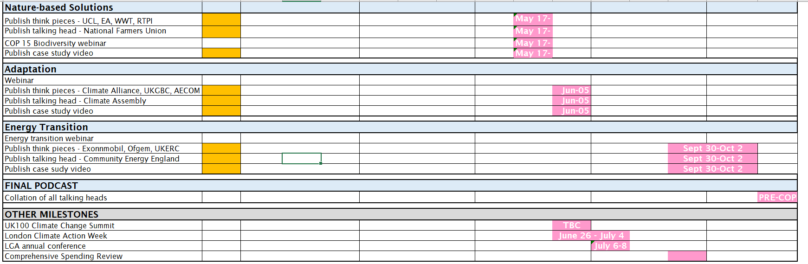
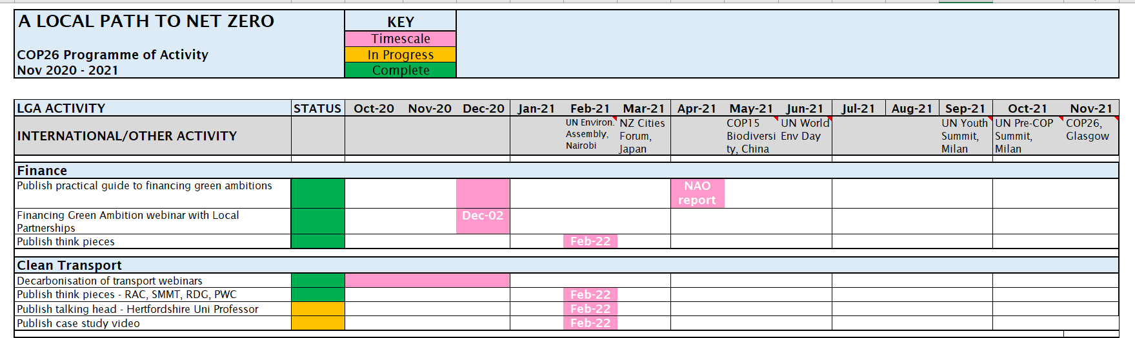
Appendix 1

